Functional Specification

Project Name Email Converter
Version Number 1.0.0
Revision Date-time 23/10/2012 12:20:00 PM
Development Project Lead Siarhei Yanusheuski

Contents
General Overview and Project Description 1
Requirements 2
Getting Started 2
Valid Email Messages 2
Output 2
Xml File 3
Project in Depth 3
Detailed diagram 3
Main Classes 4
SheduledProcess 4
ReadEmailAndConvertToXmlSpingImpl 5
How to stop the program 5
Testing 5
Logging 5

General Overview and Project Description

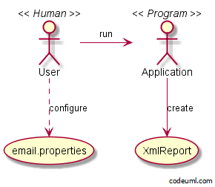

Email Converter is a simple program that reads daily reports from configurable email and converts it into xml files.

Requirements
- At least jdk-1.7
- Apache Maven 3.0.4+

Getting Started
In order to run the program take the following steps:
- git clone git://github.com/fiti128/Time.git ( you can also download zip file from https://github.com/fiti128/Time)
- cd time
- mvn install
- mvn assembly:single
- cd target
- java –jar time-1.0.0-RELEASE.jar

Valid Email Messages

Now you can send day reports to the configured email, default is kirill.iliashovitch@yandex.ru. The program will read all messages in this email but converts only valid reports. The body of your email message should contain work description, status and elapsed time exactly in such order separated by “,” or by “.” by “/”. The program will read person id and date automatically. Example of the valid email message:
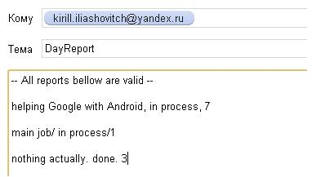

Output

The output should look like:
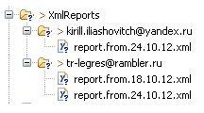
It could be only one report saved from the particular person per day. So the program will always rewrite day report with the latest email message from the particular person. The converter was designed in such way to solve human trait of making mistakes. Person has time till next day to make changes in his day report by sending new email. He has time till 23:59:59. At 00:00:00 will be next day and next file.

Xml File
Example of the output xml file:
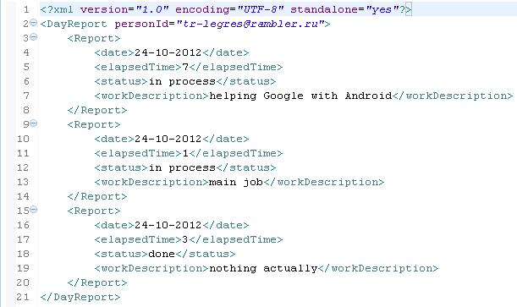

Confirmation Email

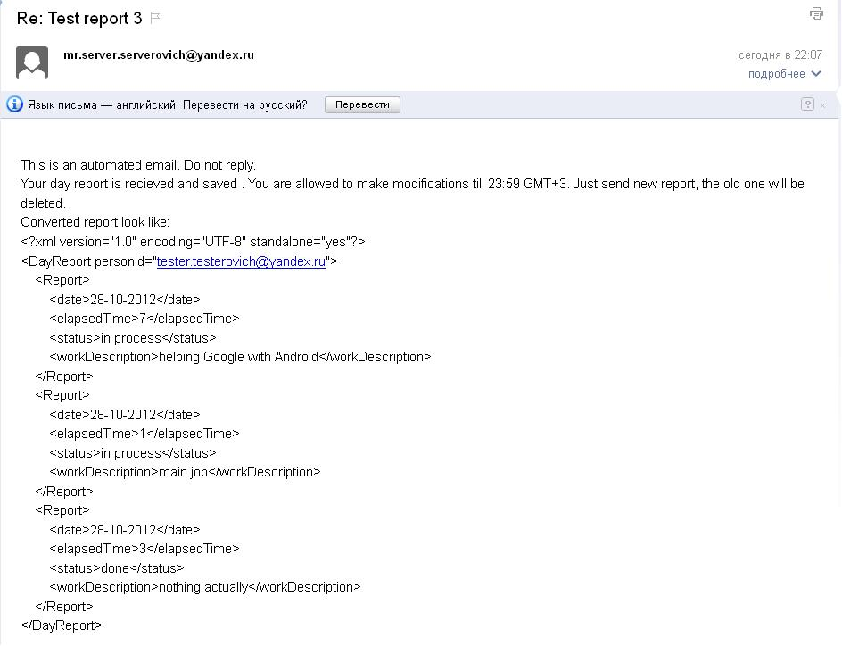

Error Email

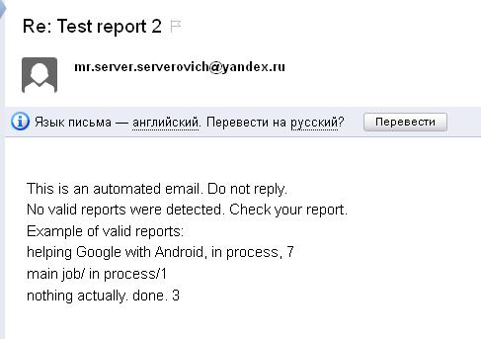

Project in Depth

Detailed diagram

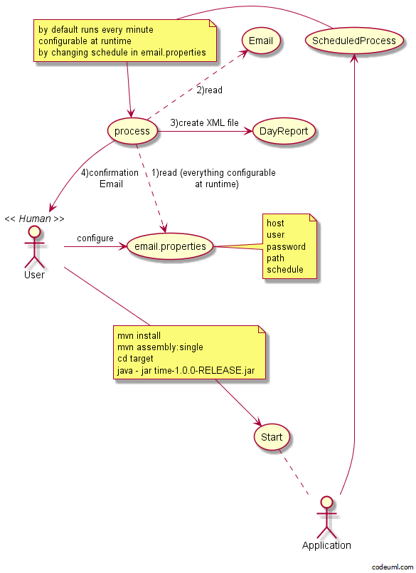

Main Classes

SheduledProcess

This class is used to provide scheduling for the program. It runs automatically when scheduledConfig.xml is loaded
When the program starts Spring automatically runs process() method in SheduledProcess class. Process() method would be invoked every minute with a fixed delay, meaning that the period will be measured from the completion time of each preceding invocation.

ReadEmailAndConvertToXmlSpingImpl
Initializing by SheduledProcess class. It loads additional spring configuration. Method execute actually does the entire job: loads email properties, reads email and converts valid ones into xml files.
Email properties are loaded every schedule so you can configure them at any moment by placing email.properties file into the folder with time-1.0.0-RELEASE.jar. Keys are: host, user, password, path. For example, you can put email.properties with body like this:
host=pop.yandex.ru
user=kirill.iliashovitch@yandex.ru
password=godBlessMe
path=D:/XmlReports/
On next schedule program will read from yandex mail service with credentials kirill.iliashovitch@yandex.ru as a user and godBlessMe as a password and will save valid reports at d:/XmlReports/

How to stop the program
You can stop the program just by adding “continue=no” line into your email.properties file. For example, put email.properties file into the folder with time-1.0.0-RELEASE.jar with body like this:
host=pop.yandex.ru
user=kirill.iliashovitch@yandex.ru
password=godBlessMe
path=D:/XmlReports/
continue=no
The program will stop at next schedule.

Testing
Complete module testing with separate configuration.

Logging
Logs are saved in logs/conveter.log relative to time-1.0.0-RELEASE.jar.

